**Microservices with Spring Boot 3 and Spring Cloud**

**Hands on**

**Creating Microservices for account and loan**

In this hands on exercises, we will create two microservices for a bank. One microservice for handing accounts and one for handling loans. Each microservice will be a specific independent Spring RESTful Webservice maven project having it's own pom.xml. The only difference is that, instead of having both account and loan as a single application, it is split into two different applications. These webservices will be a simple service without any backend connectivity.

**Step-1: Create folders**

1. Open D: drive
2. Create a folder with your **employee ID** (22341A4511)
3. Inside that, create a folder microservices
4. Final path: D:\22341A4511\microservices

**Step-2: Create Account Microservice**

1. **Generate Spring Boot Project**
   1. Go to: [https://start.spring.io](https://start.spring.io/)
   2. Type out:
      * **Group**: com.cognizant
      * **Artifact**: account
   3. Add the following Dependencies:
      * Spring Boot DevTools
      * Spring Web
   4. Click **Generate**
   5. download and extract the zip
   6. Place the extracted account folder into D:\22341A4511\microservices

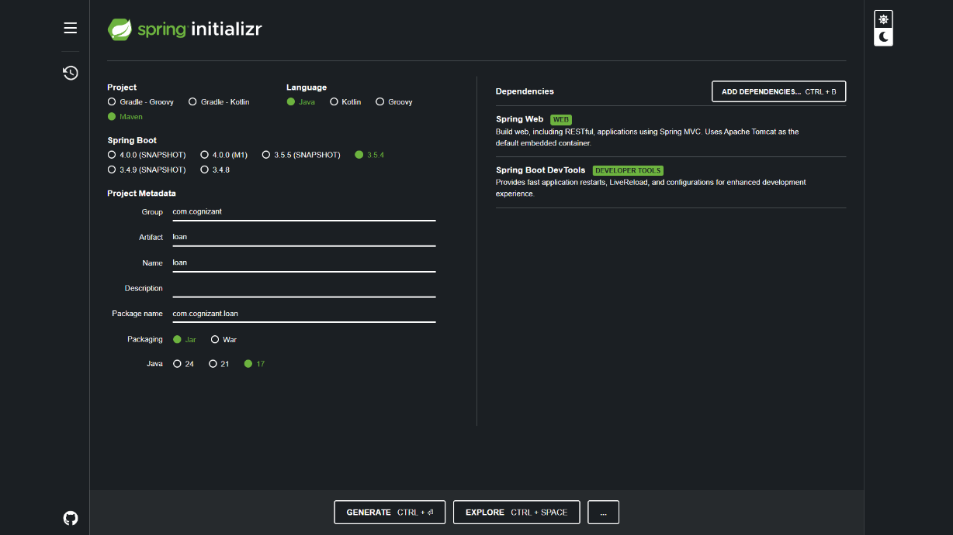

1. **Build the Account Service**

* Open cmd and run: mvn clean package
* You should see a BUILD SUCCESS message

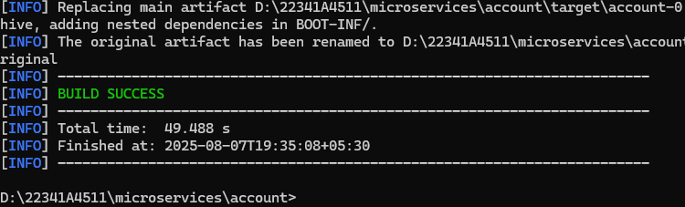

1. **Import into Eclipse**

File > Import > Existing Maven Projects> Select account folder

1. **Create Controller**

* Create a class AccountController.java inside com.cognizant.account.controller package:

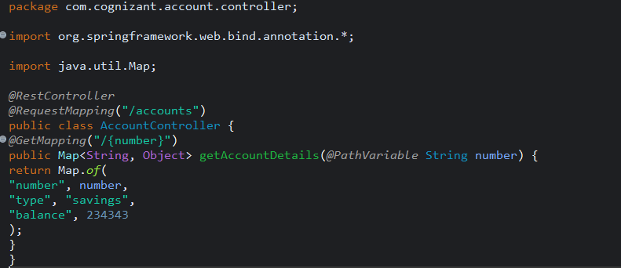

1. **Run and Test**
   1. Run the main class AccountApplication.java
   2. 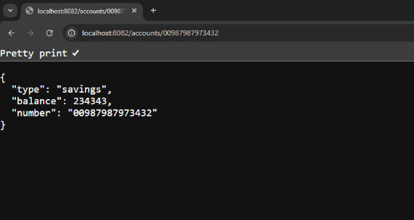Open browser > <http://localhost:8082/accounts/00987987973432>

**Step-3: Create Loan Microservice**

1. **Generate Spring Boot Project**

* Go to: [https://start.spring.io](https://start.spring.io/)
* Type out:
  + **Group**: com.cognizant
  + **Artifact**: loan
* Add the following Dependencies:
  + Spring Boot DevTools
  + Spring Web
* Download, extract, and place it in the the micorservices folder D:\22341A4511\microservices\loan

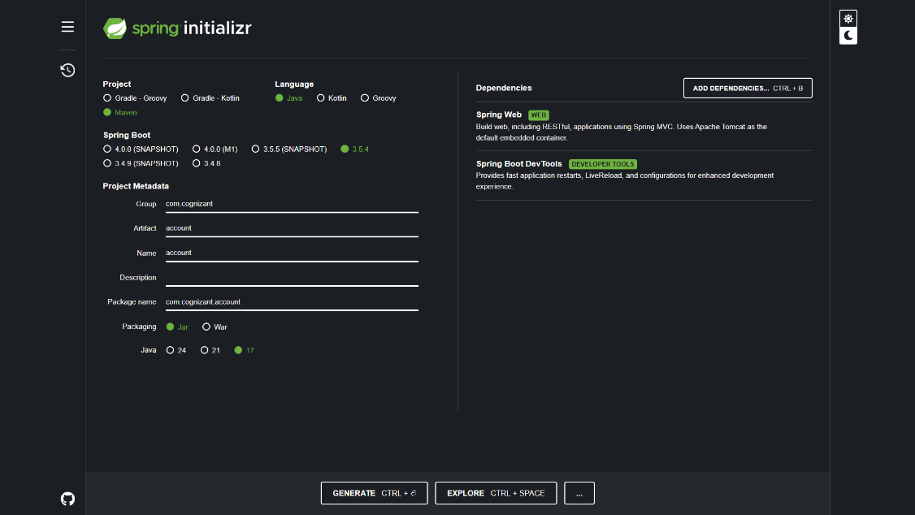

1. **Build the Loan Service**

In cmd: mvn clean package

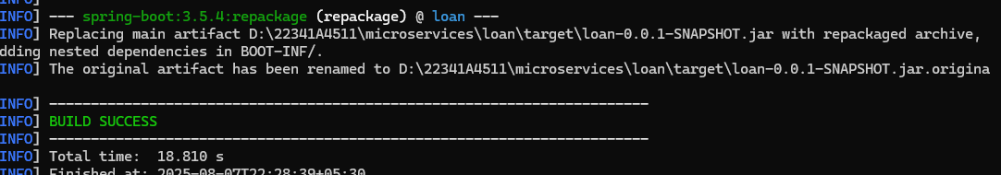

1. **Import into Eclipse**

File > Import > Existing Maven Projects> Select loan project

1. **Create Controller**
   1. Create class LoanController.java in com.cognizant.loan.controller package:

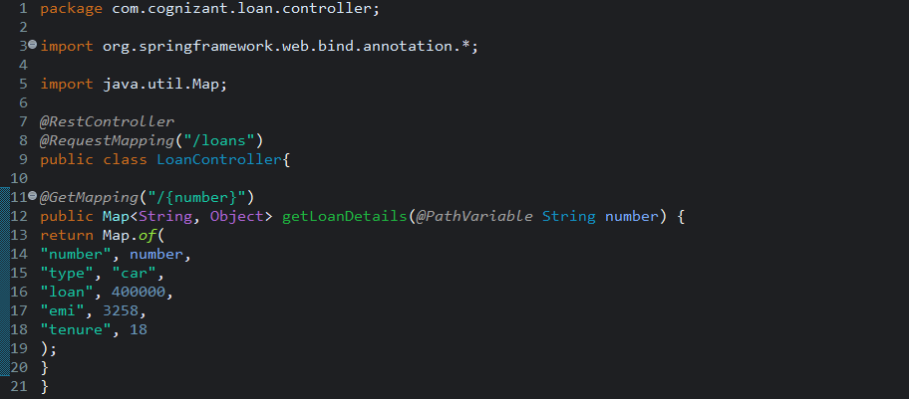

1. **Run and Test**
   1. Run the LoanApplication.java main class
   2. Open browser> <http://localhost:8082/loans/H00987987972342>

